kThe word trignometry is devided from 2 greek words
(1) Trigonon and
(2) Meetron
Trignon means triangle and metron means measure So, is science of measuning angle .A very interesting branch, it is used in almost all other branches of mathematic whether it be coordinatc goemetry or it be calculus.
For a given angle in a right angle these ate six fossible ratios of 2 sides and hence there are 6 trignometric functions. These are extremely useful in simplefying many cliculations in mathematics. So lets stady these in more details.
Trignometric functions:
Let O be centre if circle of radius r . Let a may po form an angle at centre of circle. Drop a pm.
So, in OPM we obserre.
sin = , cos=
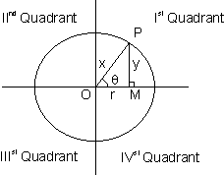
ton = 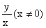;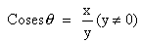
Further more about these 6 trignometric ratios is covered in this table.
Illustration 1.
Find the sol^{r} of the equation e^{ln cos x} = 2 ?
e^{ln cos x} = cos x ^{lne} = cos x
cos x = 2
Now the range of cos x is - 1 to 1 .
So, the equation has no solution .
Trignometric function of allied angles:
If is any angle then - , etc are called allied angles of
Remork: (1) If we have allied angle where n is any integer then ratio remains the some and sign ( +ve and -ve) is given according to the quadrant in which lies
(assuming Ist Quadrant).
(2) If we have allied angle 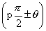where P is an odd integer then ratio changes i.e 'sine' changs to 'cosine' ; 'cosine' changes t 'sine'; tangent and 'cosecant' changes to 'secant'changes to 'cotangent', 'secant' changes t 'cosecant' and ' cosecant' changes to 'secant' The sign (+ve or -ve ) is given according t quadrant in which lies(assumtg IstQuadrant.
Illustration 2:
Find the value of tan (1020⁰) ?
1020⁰ = 10 X 90⁰ + 30⁰
If lies in the IV ^{th} Quadrant.
So, tan (10 X 90⁰ + 30⁰ ) = - tan 30⁰
= -
Trignometric Ratios of Compound angles:
(1) sin (A + B) = sin A cos B + cos A sin B
Why?
Draw < A o B = < A and < boc = < B .
And find any point P on oc.
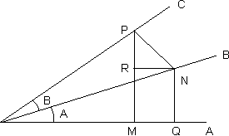
Draw PM and PN to OA and oB respectively.
Through N draw NR parrallel to AO t meet MP in R and other N OA
< R P N = 90⁰ - < P N R
= < R N O = < NO = < A
So, sin (A + B) = sin A o P = 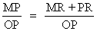
= 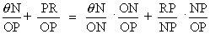
= sin A cos B + cos A sin B .
(2) os (A + B) = cos A cos B - sin A sin B
Why ?
cos(A + B) = sin( - (A + B))
= sin(( - A) - (-B))
= sin ( - A) cos (- B) + cos ( - A) sin(- 6)
= cos A cos B - sin A sin B .
3) sin (A + B) = sin A cos B - cos A sin B
4) cos (A + B) = cos A cos B + sin A sin B
5) tan (A + B) = 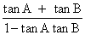
6) tan (A + B) = 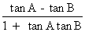
7) cot (A + B) = 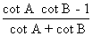
8) cot (A + B) = 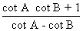
Illustration 3:
If A + B = 45 ⁰, show that (1 + tan A) (1 + tan B) = 2.
Ans:- tan (A + B) =
1 = ( A + B = 45º.so tan (A + B) = 1 )
So, tan A + tan B + tan A tan B = 1
or, tan A + tan B + tan A + tan B + 1 = 2
or, (tan A + 1) (tan B + 1) = 2
Some more farmulae:
1) 2 sin A cos B = sin (A + B) + sin(A - B)
Why ?
Add sin (A + B) = sin A cos B + cosA sin B
& sin (A + B) = sin A cos B - cos A sin B
2) 2cos A sin B =sin(A + B) - sin(A - B)
3) 2cos A cos B =cos(A + B) - cos(A - B)
4) 2sin A sin B =cos(A + B) - cos(A - B)
5) sin C + sin D = 2 sin 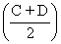cos 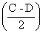
Why ?
Put A + B = C
and A - B = D
in sin (A + B) + sin (A - B) = 2sin A cos B .
6) sin C - sin D = 2 cos sin
7) cis C + cos D = 2 cos cos
8) cos C - cos D = 2 sin sin
Illustration 4:
Proove that sin 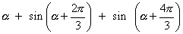= 0
Ans:- sin
= sin
= [ using sin()= sin, sin () = - sin]
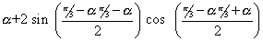
= sin
= sin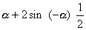
= sin - sin - sin
= 0
Trignometri Ratios multiples of an angle :
1) sin 2 = 2sin cos= 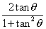
why ? sin (A +B) = sin A cos B + cos A sin B
Put A = B =
So, sin 2 = 2sin cos
= 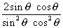
=
2) cos2 = cos² -sin² = 1 - 2 sin²
= cos² - 1
= 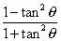
3) tan 2 = 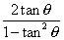
4) sin 3 = 3 sin - 4sin²
Why ?
sin3 = sin ( + 2 )
sin ( + 2) = sin cos²+ cos sin²
= sin ( 1 - 2 sin²) + cos (2sincos)
= sin - 2sin³ + 2sin (1 - sin²)
= 3 sin - 4 sin³
5) cos 3 = 4 cos³ - 3 cos
6) tan 3 = 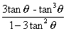
Illustration 5:
sin x + sin y = a and cos x + cos y = b , show that
sin (x + y) = 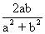and tan (x - y) 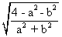
Ans:- sin x + sin y = a
=> 2 sin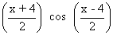 = a ...................(1)
cos x + cos y = b
=> 2 cos = b ...................(2)
=> tan 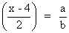
sin (x + y) = 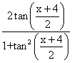
= 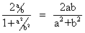
Squaring (1), (2) and adding .
4 cos²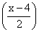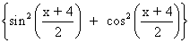 = a² +b²
or cos² = 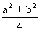
sin² = 1 - 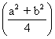
= 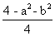
tan²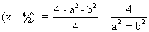
tan =
Illustration 6:-
Find the value of sin18⁰ ?
Ans:- Let 18⁰
So, 5 = 90⁰
=> 2 = 90⁰ - 3
Or, sin 2 = sin (90⁰ - 3)
=> sin 2 =cos3
=> 2sin cos= cos(4 cos² - 3)
=> 2sin = 4cos² - 3 ( cos 0)
= 1 - 4sin²
=> 4sin² + 2 sin - 1 = 0
So, sin = 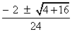
= 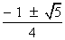
But since sin > 0 we have sin =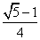
So, sin 18 º =
Dumb Question:- Why cos is not equal to 0 ?
Ans: cos 90⁰ si O and cos Oº is 1
So, cos being a continous function.
cosi.e. cos 18⁰ would have some value between o and 1.
Some nice manipulations:
1)
Why ? = cos² sin² 2sin cos
= 1 2sincos
= 1 sin²
2) 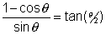
Why ?
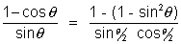
= 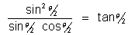
3) cos Asin A =
Why !
cos A sin A =
=
=
Expressing sin in terms of sin A:
=
=
The ambiguity of sign is removed from following figure.
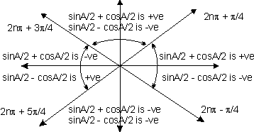
Dumb Question: Where does this diagram come from ?
Ans:-
So, if is in I ^{st} or IInd quadrent
then is + ve.
So, A/2 lie from 2_{n} for to be + ve
Similarily for
Illustration 7:
If cos 25⁰ + sin 25 ⁰ = P , then find value of cos 50⁰ in trems of P ?
Ans:- cos50⁰ = cos² 25 ⁰ - sin² 25⁰
= (cos 25⁰ + sin25⁰)(cos 25⁰ - sin25⁰)
P(cos25⁰ - sin25⁰)
Also, (cos25⁰ - sin25⁰)² + (cos25⁰ - sin25⁰)² = 1 + 1
cos25⁰ - sin25⁰ = +
(+ve sign as cos 25⁰ > sin 25⁰)
cos50⁰ =
The qreatest and least valume of expression (a sin + b cos)
- a sin + b cos
Why?
Let a = r cos
b = r sin so that r =
So, a sin + b cos = r (sin cos + cossin )
= r sin ( + )
Now sin ( + has minimum and maximum value as + 1 and - 1 esppectively.
So, - r rsin ( + ) r
So, - a sin + b cos
Illustration 8:
Find the minimum and maximum value of
6 sin x cos x + 4cos² 2x ?
Ans:- 6 sin x cos x + 4cos² 2x = (2sin x cos x ) + 4cos 2x
= 3 sin 2x + 4cos 2x .
- 3sin 2x + 4cos2x
=> Minimum value of 6sin x cos x + 4 cos 2x is - 5
and maximum value is 5.
Sum of sine and cosine senies when angles are in AP .
(1) sin + sin = 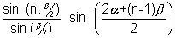
Why ?
2sin
2sin
2sin
By adding these n lines we have.
2sin
= 2sin 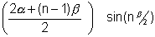
S = 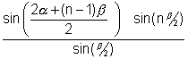
(2)
= 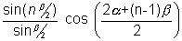
Illustration 9:
Find sum of sin -............+ 0 n terms. Ans:- Now, sin
sin
sin
........................................................
Hence the series is
sin ............
= 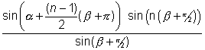
= 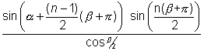

Conditional Identities.
If A + B + C = 180º then .
(i) sin 2A + sin 2B + sin 2c = 4sinA sin B sinC.
Why ?
A + B + C = 180º
So, A + B = 180º - C
sin(A + B) = sin C
cos (A + B) = - cos C
sin 2A + sin 2B + sin 2C = 2 sin (A + B) cos (A - B) + 2sin C cos C.
= 2sin C cos (A - B) + 2sin (- cos (A + B))
= 2sin C (cos (A - B) - cos (A + B))
= 2sin C (2sin A sin B)
= 4sin A sin B sin C .
(ii) cos 2A + cos 2B + cos 2C = - 1 - 4cos A cosB cosC
(iii) sinA + sinB + sinC = 4 cos
(iv) cosA + cosB + cosC = 1 + 1 + 4sin
(v) tanA + tanB + tanC =tanA tanB tanC
Why ?
tan (A + B + C) = 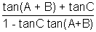
= 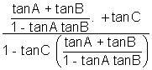
= 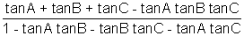
So, since tan (A + B + C) = tan (180⁰) = 0
So, tanA + tanB + tanC - tanA + tanB + tanC = 0
=> tanA + tanB + tanC = tanA + tanB + tanC.
(vi) cotA + cotB + cotA + cotC + cotB cotC = 1
(vii)
(viii)
Illustration 10:
If A + B + C = 180 º then prove that
sin² A + sin² C = 2 + 2 cosA cosB cosC.
Ans:- sin²A + sin²B + sin²C = 1/2 (1 - cos²A + 1 - cos²B + 1 - cos²C)
= (3 - (cos2A + cos2B + cos2C))
= [3 - (- 1 - 4cosA cosB cosC)]
= [4 + 4cosA cosB cosC]
= cosA cosB cosC
= 2 + 2 cosA cosB cosC
1) Question - If sin + cosec = 2 then what is the value of sin² + coses².
Solution:- sin² + cosesc² = (sin + cosec)² - 2sin cosec
= (1 + 1)² - 2.1 = 2
2) Prove that 2(sin⁶ + cos⁶) - 3(sin⁴ + cos⁴ ) + 1 = 0
Solution:- L.H.S. 2 [ (sin² + cos²)³ - 3sin²cos²(sin²+ cos²) ] -[ (sin² + cos²)³ - 3sin²cos²] + 1
= 2 [ 1 - 3 sin²cos²] - 3 [ 1 - 2sin²cos²] + 1
= 0
3) Prove that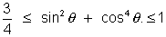 for all real
Solution sin² + cos⁴ - cos² + 1
= 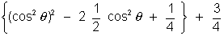
= 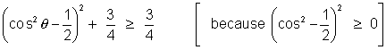
Also, sin² + cos² = cos⁴- cos² + 1
= cos²(cos² - 1) + 1
= 1 - sin² cos² 1
[ becaise sin² cos² 0]
4) Evaluate sin 78 º - sin66º - sin42 º + sin6º
= (sin 78º - sin42º) - ( sin66º - sin6º)
= 2cos 60º sin18º - 2cos36º. sin30º
= sin18º - cos36º
=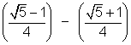
= -
(5) If a then find the maximum value of sinA sinB .
Solution:- sinA sinB = 2 sinA sinB
= [ cos (A - B) - cos (A + B)]
= [cos (A - b) - cos 90º]
= cos (A - B)
So maximum valuie of sinA sinB =
(6) Prove that cosec 20º - sec 20º = 4
Soluction- L.H.S. = 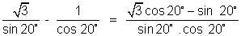
= 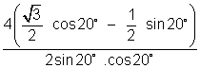
=4.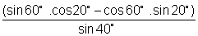
= 4. 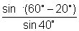
= 4.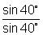
= 4 = R.H.S.
(7) Find the value of, 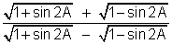
When | tanA | < | and | A | is acure,
Solution:-
=> 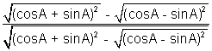
=>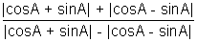
=> 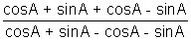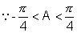and in this interval casA > sinA }
=>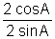 => cotA
When |tanA| < 1 and |A| is acute.
Q. Find a and b such that for all x, a 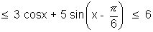
Soluction:- 3 cosx + 5 sin(x - ) = 3 cosx + 5 sinx cos - 5 cosx sin
= (3 - 5/2)cosx + 5 sinx
= cosx + 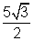sinx
a = 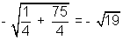
and b =
(9) Find the maximum and minimum value of cos² - 6 sin cos + 3 sin² + 2
Soluction:- cos² - 6 sin.cos + 3 sin² + 2
= (1 - sin²) - 3 sin2 + 3 sin² + 2
= 2 sin² - 3 sin2 + 3
= (1 - cos2) - 3sin2 + 3
= 4 - (cos2 + 3 sin2) ................................................. (i)
as we have -
or 4 -

(10) If a triangle ABC show that - 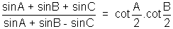
Solution:- Dr = sinA + sinB - sinC
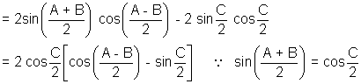
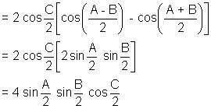
Similarly N_{r} = 4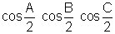
L.H.S. = 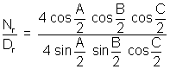
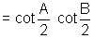
(11) Prove that tanA + 2 tan2A + 4 tan 4A + 8 cot 8A = cot A
L.H.S. = tanA + 2 tan2A + 4 tan4A + 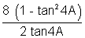
= tanA + 2 tan2A + 4 cot4A
= tanA + 2 tan2A + 4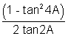
= tanA + 2 cot2A
= tanA + 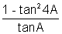
= cotA = R.H.S.
(12) If 2 cosA = x + 1/x , 2 cosB = y + 1/y show that 2 cos(A - B) = x/y + y/x
Soluction:- 2 cosA = x + 1/x since 4 sin²A = 4 - 4 cos²A
= 4 - (x + 1/x)²
4 sin²A = - [(x + 1/x)² - 4]
4 sin²A = - i²[(x - 1/x)²]
2 sinA = i(x - 1/x)
Similarily 2 cosB = y + 1/y
2 sinB = i(y - 1/y)
Now, 2 cos(A - B) = 2[cosA cosB + sinA sinB]
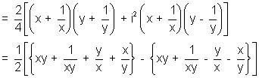
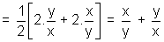= R.H.S.
Medium
Q-1 Determine the smallest positive value of x(in degrees ) for which tan (x + 100⁰) = tan (x + 50⁰) tan x. tan (x - 50⁰)
Soluction:- Rearranging expression-
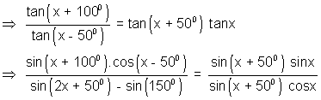
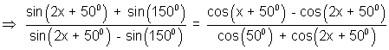
Applying componedo and dividendo, we get-
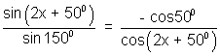
=> cos50º + 2sin (2x + 50º) . cos (2x + 50º) = 0
=> cos 50º + sin (4x + 100º ) = 0
=> cos50º + cos (4x + 10º ) = 0
=> cos (2x + 30º) cos(2x - 20º ) = 0
=> x = 30º , 55º
The smallest value of x = 30º
Dump Question:- Why we rearranged tha (x + 100º) = tan (x + 50º)tan x tan(x -50º)
as 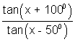= tan(x + 50º) tanx.
Ans:- Well the motiration behind doing this was the fact that the sum of x + 100º and x - 50º is 2x + 50 º and also the sum of x + 50º and x is 2x + 50º
And, what more the variable x is removed when we substract the one angle from another.
The usefulness of this obserration is clearly when we use compendo and dividerdo.
Question:- If 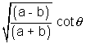, prove that (a - b cos2)(a - b cos2) is independent of and .
Soluction:- Let us put tan = t₁ and tan = t₂
t₁².t₂² = 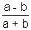......................................................... (i)
Also, cot2 = 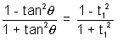
cos2 = 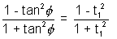
Now a - b cos2 = a - b 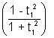
= 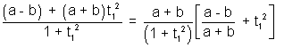
= 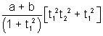 [by (i)]
= 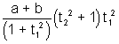
Similarily (a - b cos2) = 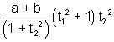
Hence a - b cos2)(a - b cos2) = (a + b)²t₁²t₂² = a² - b²
Which is independent of and .
Q. Show that 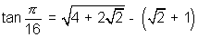
Soluction:- We know 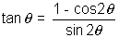where 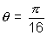
Also 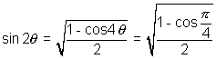
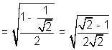
and 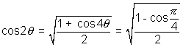
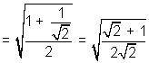
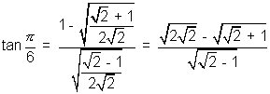
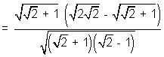
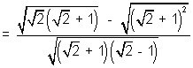
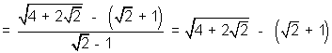
Dumb Question:- How should I approach when I look such a question for first time ?
Ans:- Look, here was the anle and so we observed that if some how 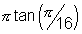could be expressed in tems of then our work will be done and so we procceded.
Q. In any triangle ABC prove that
Sin³A cos(B - C) + sin³B cos(C - A) + sin³C cos(A - B) = 3 sinA sinB sinC
Solution:- L.H.S. = sin²A sin(B + C) cos(B - C) + sin²B sin(C + A) cos(C - A) + sin²C sin(A + B) cos(A - B)
= sin²A (sin2B + sin2C) + sin²B (sin2C + sin2A) + sin²C (sin2A + sin2B)
= sin²A (sinB cosB + sinC cosC) + sin²B (sinC cosC + sinA cosA) + sin²C (sinA cosA + sinB cosB)
= sinA sinB (sinA cosB + cosA sinB) + sinB sinC (sinB cosC + cosB sinC) + sinC sinA (sinA cosC + cosA sinC)
= sinA sinB sin(A + B) + sinB sinC sin(B + C) + sinC sinA sin(A + C)
= 3sinA sinB sinC = R.H.S.
Dumb Question:
How did sinA sinB sin(A + B) + sinB sinC sin(B + C) + sinC sinA sin(A + C) became equal to 3 sinA sinB sinC.
Ans:- Since A + B + C = 180⁰ (Givien that A, B, C are angles of )
So, A + B = 180⁰ -C
and thus sin(A + B) = sin(180⁰ - C)
= sinC
So, sinA sinB sin(A + B) = sinA sinB sinC
Similarily sinB sinC sin(B + C) = sinA sinB sinC
and sinA sinC sin(A + c) = sinA sinB sinC
Q. Show that for all real , the expression, a sin² + b sin cos + c cos² lies between.
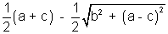and 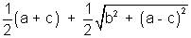
Soluton:- Expression = (1 - cos2) + sin2 + (1 + cos2)
= 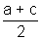+ ( sin2 - 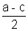cos2)
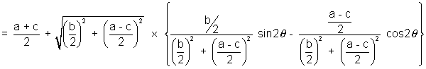
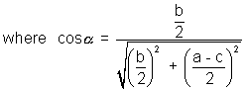
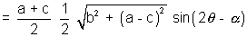
But - 1 sin(2 - ) 1
maximum value of expression-
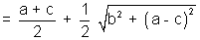
and minimum value of the expression-
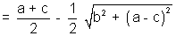
Q-6. If tan + sin = m and tan - sin = n then show that m² - n² = 4
Solution:- (m + n) = 2 tan , m - n = 2 sin
m² - n² = 4 tan. sin
4 = 4
= 4 sin
= 4 sin tan
Dumb Question:-
Why was equated to tan and not - tan ?
Ans:- Yes actually it could have been both, nothin is mentioned here in the question in the question so this ambiquity has arised.
Q-7. Evaluate 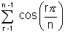
Solution:- Sum = 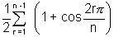
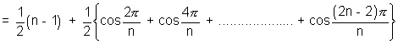
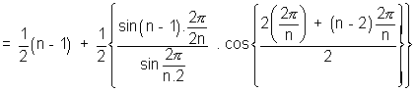
Using-
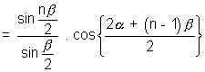
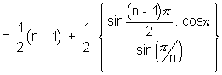
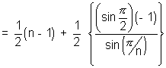
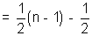
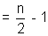
So, 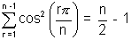
Hard
Q-1. If m² + m¹² + 2mm¹ cos = 1
n² + n¹² + 2nn¹ cos = 1 and mn + m¹ n¹ + (mn¹ + m¹ n) cos = 1 then prove that m² + n² = cosec²
Solution:- m² + m¹² + 2mm¹ cos
or (m²cos² cos² + m² sin²) + m¹² + 2mm¹ cos = 1
or m² cos² + 2mm¹ cos + m¹² = 1 - m² sin²
or (m cos + m¹)² = 1 - m² sin² ...............................................(i)
Similaily, n² + n¹² + 2nn¹ cos = 1
=> n²(n cos + n¹)² = 1 - n² sin² ...............................................(ii)
Finally, mn + m¹n¹ + (mn¹ + m¹n cos = 0
=> (mn cos² + mn sin²) + m¹n¹ cos + m¹ n cos = 0
=> mn cos² + m¹ n cos + m¹ n¹ + mn¹ cos = -mn sin²
=> n cos(m cos + m¹) + n¹ (m¹ + m cos) = - m sin²
=> (m cos + m¹)(n cos + n¹) = - mn sin²
=> (m cos + m¹).(n cos + n¹)² = m²n² sin⁴
=> (1 - m² sin²)(1 - n² sin² = m²n² sin⁴ (Using (i) and (ii))
=> 1 - (m² + n²) sin² + m²n² sin⁴ = m²n² sin⁴
=> (m² + n²) sin² = 1
=> m² + n² = cosec²
Q-2. Show that 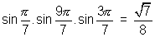
Solution: Let 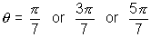 (Note 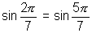)
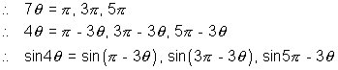
or
or 2 sin² cos2 = 3 sin - 4 sin³
or 4 cos.cos2 = 3 - 4 sin² ( sin 0)
or 4 cos.(2 cos² - 1)
This is a third degree equation in cos and each of 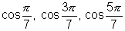satisfied it.
roots of (1) are
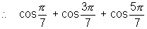= sum of roots = - 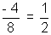................................................. (2)
............................................. (3)
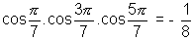 .................................................................................... (4)
Now 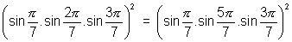
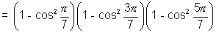
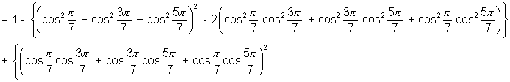
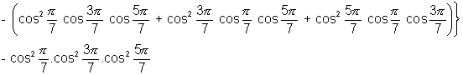
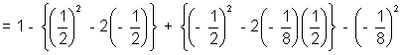 [Using (2), (3), (4)]
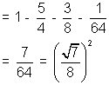
Hence 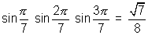
Dumb Question:- How was equated to 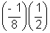.
Ans:-
=
Q-3. If A + B + C = , sinA sinB sinC = P and cosA cosB cosC = 2 then otain the cubic equation whoose roots are tanA, tanB and tanC.
Solution:- The required cubic equation is
(x - tanA)(x - tanB)(x - tanC) = 0
or x³ - (tanA + tanB + tanC) x² + x(tanA tanB + tanB tanC + tanC tanA)
- tanA tanB tanC = 0 ...............................................(1)
Now tanA. tanB. tanC = 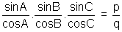.........................................................................(2)
Also tan(A + B) = tan( - C) = - tanC
or 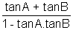= - tanC
or tanA + tanB + tanC = tanA tanB tanC = ..............................................................(3) [Using (2)]
Now sin²A + sin²B + sin²C
= [3 - (cos2A + cos2B + cos2C)]
= [3 - {2 cos(A + B).cos(A - B) + 2 cos²C - 1}]
= [4 - {- 2cosC cos(A - B) + 2cos²C}]
= [4 + 2 cosC{cos(A - B) + cos(A + B)}]
= 2(1 + cosA cosB cosC) = 2(1 + q)
sin²A sin²B sin²C (cosec²B cosec²C + cosec²C cosec²A + cosec²A cosec²B ) = 2(1 + q)
or p²{(1 + cot²B)(1 + cot²C) + (1 + cot²C) (1 + cot²A) + (1 + cot²A) (1 + cot²B)} = 2(1 + q)
or p²{3 + 2 (cot²A + cot²B + cot²C) + cot²B cot²C + cot²C cot²A + cot²A cot²B)} = 2(1 + q)
or p²[3 + 2{cotA + cotB + cotC)² - 2(cotA cotB + cotB cotC + cotC cotA)} + {(cotB cotC + cotC cotA + cotA cotB)² - 2 cotA cotB x cotC(cotA + CotB + cotC)}] = 2(1 + q)
or p² [3 + 2{(cotA + cotB + cotC)² - 2
+ {1 - 2.(cotA + cotB + cotC)}] = 2 (1 + q) ..........................................(4)
[cotA. cotB = 1 if A + B + C = ]
Let y = tanA tanB + tanB tanC + tanC tanA
= tanA tanB tanC(cotC + cotA + cotB)
= (cotA + cotB + cotC )
cotA + cotB + cotC = ........................................................(5)
(4) gives
or 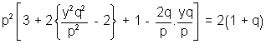
or 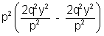-2(1 + q)
or q²y² - q²y - (1 - q) = 0
y = 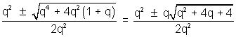
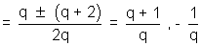........................................................... (6)
From (1), (2), (3), (4), (5) and (6),
x³ - x² + 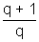x - = 0 where y =
or x³ x² - x - = 0 when y = -
The required equation is
qx³ - px² + (q + 1)x - p = 0
or qx³ - px² - x - p = 0
Dumb Question:-
How does suddenly we started evaluating sin²A + sin²B + sin²C ?
Ans:- The aim that we were trying to achievc at that point of time was to calculat the value of tanA tanB + tanB tanC + tan A tanC.
Now when we try to evaluate this we realize that cotA + cotB + cotC needs to evaluated and thus we tried to make a equation is terms of cotA + cotB +cotC
So, all this factors were take in account and then only the sin²A + sin²B + sin²C was eqaluated.
Key words:
(1) Trigonometry
(2) Quadrant
(3) Sin
(4) Cos
(5) Tan
(6) Cot
(7) Sec
(8) Cosec
(9) Allied angles.
(10) Compound angles.
(11) Perpendicular
(12) Hypotenuse
(13) Base

